TRIO 2018 Annual Report

# Introduction

Cuyahoga Community College (Tri-C), located in Cleveland, Ohio, has a long history of working with the federal TRIO programs. These programs are “federal outreach and student services programs designed to identify and provide services for individuals from disadvantaged backgrounds.”1 Having been involved with TRIO since 1968, TriC is well versed in the intricacies of managing budgets and upholding statutory and regulatory requirements for the TRIO programs. As Tri-C itself puts it:

*Cuyahoga Community College takes pride in its almost 50-year history of stewardship of federally-funded TRIO grants. It has gained knowledge through accessing a wealth of internal expertise, thoughtful staffing decisions, taking advantage of professional development opportunities, and learning from our participants, colleagues and student-serving networks.*

In fall 2016, Tri-C was awarded a grant by the United States Department of Education (USDE) to set up a TRIO Budget, Legislation and Regulations Training Program Office. This new office would then offer trainings (among other aspects not covered in this report) to TRIO program administrators at institutions of higher learning throughout the United States. The ultimate goal of the grant is to increase the capacity of administrators throughout the country to effectively manage the budgets of their TRIO programs.

During 2017, three rounds of training sessions were offered, each of which had a different format (in person training, online training, and hybrid- a mix of in person and online trainings). In 2018, there were five training sessions, three in person, one online, and one hybrid

This report is an assessment of the performance in and satisfaction with these trainings. In addition to looking at overall satisfaction, the report breaks down the data to compare across types of session (in person, online, and hybrid) and across the last two years. It is hoped that lessons learned from this report will allow the Cleveland-based community college to improve its trainings in subsequent years.

# Demographics of Training Participants

In 2018, 217 participants took part in TRIO trainings.

Table 1: Number of Participants by Training Session

| **Session** | **Number of Participants** |
| --- | --- |
| 2018 Online | 62 |
| 2018 Hybrid | 20 |
| 2018 In Person (June) | 32 |
| 2018 In Person (July) | 19 |
| 2018 In Person (August) | 84 |

## Map of participants

Participants came from across the United States. The maps below show the locations of the institutions with which participants are associated (note that the few participants from Hawaii and Alaska are not shown in order to keep the maps small in size).

Figure 1: Map of Institutions Represented at TRIO Trainings 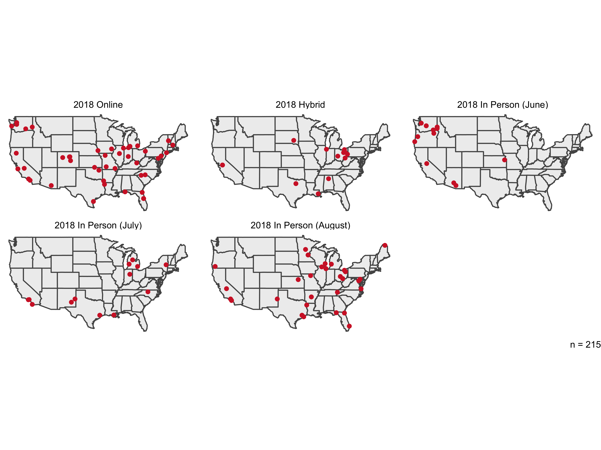

## First-time attendees

For most participants, the training they attended was their first such training. The highest percentage of those saying they had attended a previous session in 2018 was in the June in person session, when 45 percent were returning for a follow-up session.

Figure 2: Participants by Whether They Attended a Previous Training Session 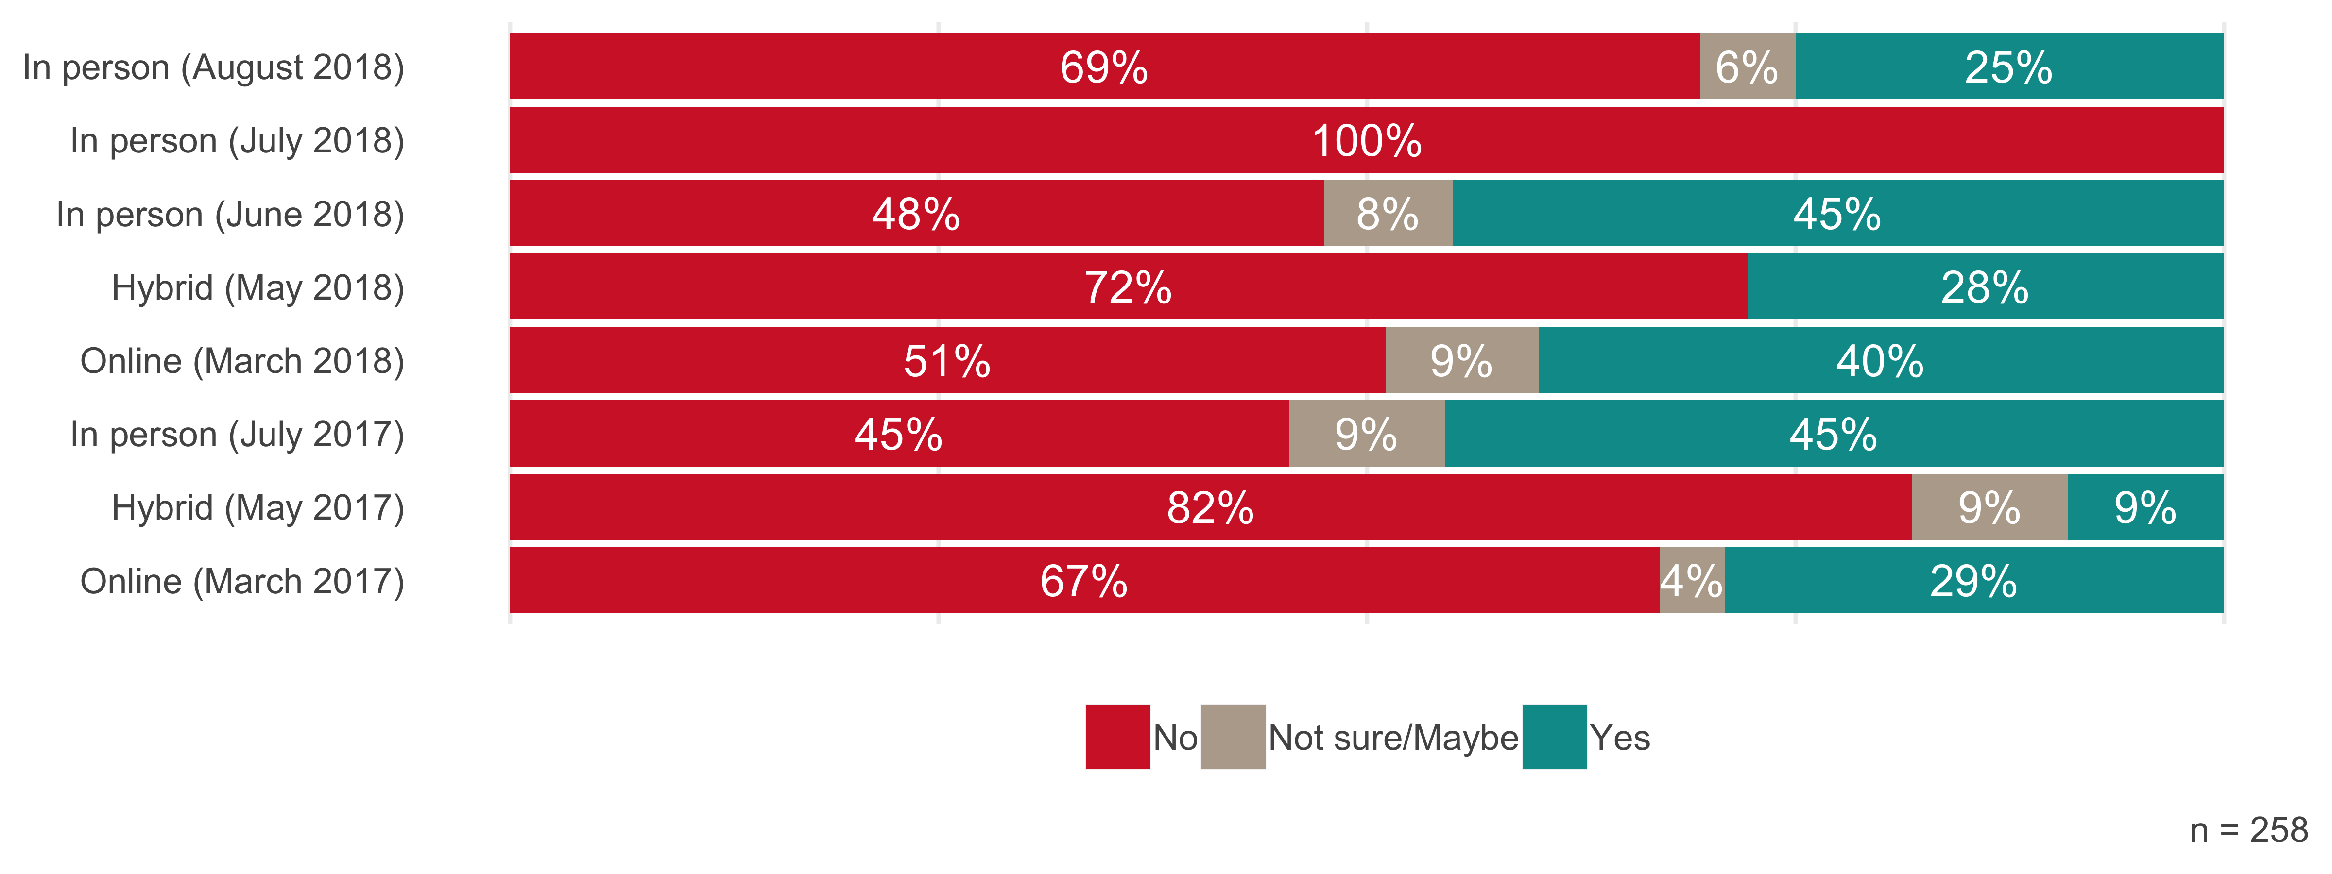

## Size of departments

Participants were asked about the size of the departments they work in. As seen in the figure below, the vast majority of departments had 10 or fewer other staff members (in addition to the participant).

Figure 3: Number of Other Staff in Participants’ Departments

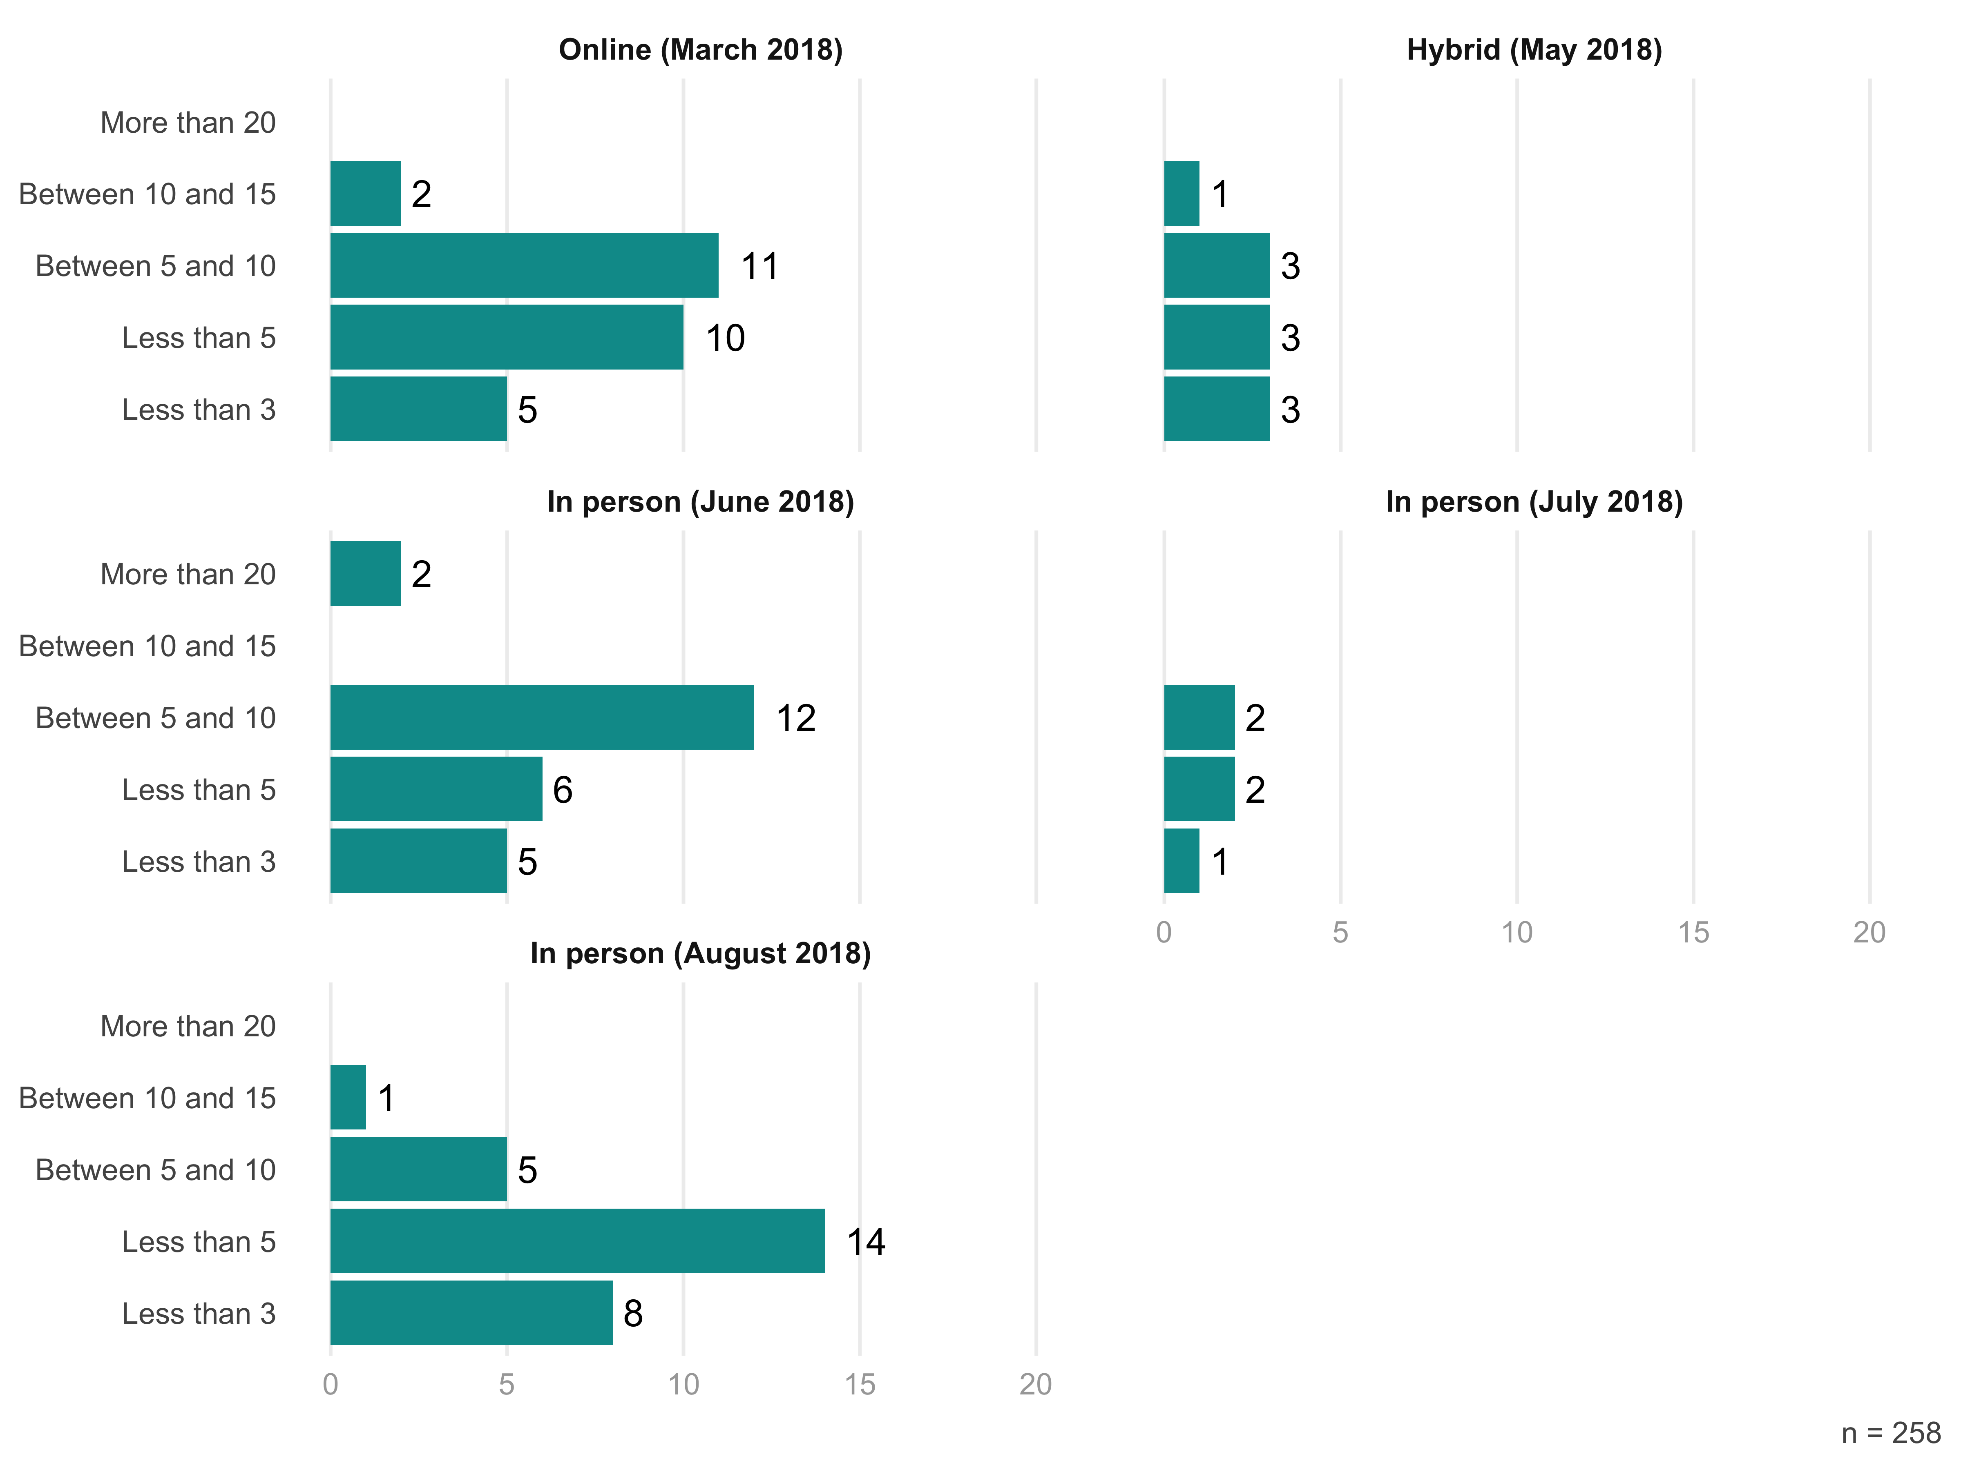

## Decision makers

Participants also responded to a question asking whether they were the primary decision maker in their department. Of those who participated in 2018, 39 percent said they were. The full breakdown by training session is below.

Figure 4: Were TRIO Participants Decision Makers in Their Departments? 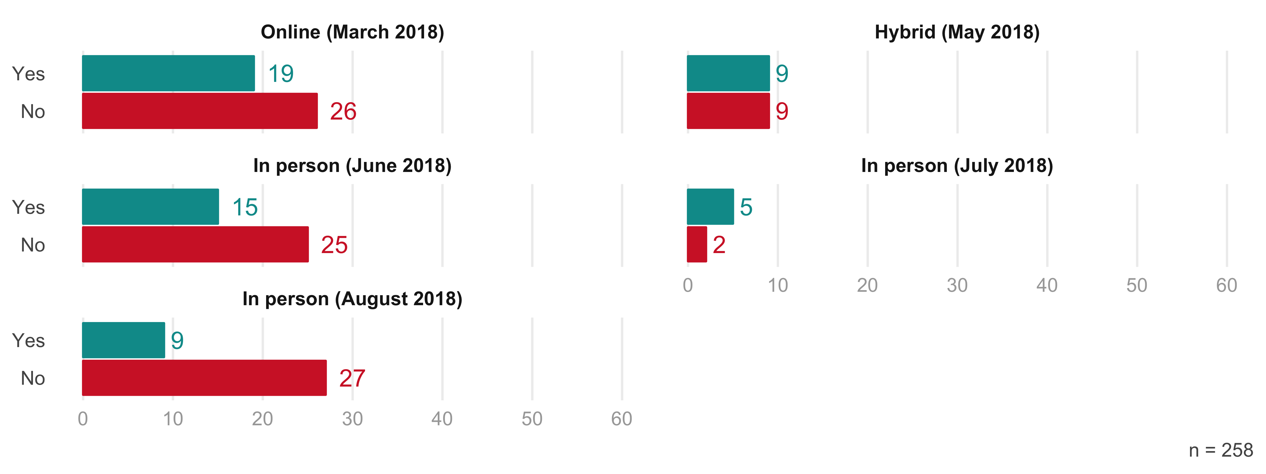

## Challenges they face

# Training Sessions

## List of courses

The TRIO training sessions this year included all of the courses from 2017 as well as one additional course: TRIO Management and Effective IT Controls.

Table 2: List of Courses

| **Courses** |
| --- |
| COSO integrated internal control framework |
| Educational Opportunity Center |
| Educational Talent Search |
| Student Support Services & McNair |
| TRIO Budget I |
| TRIO Budget II |
| Uniform Guidance |
| Upward Bound and Upward Bound Math and Science |
| Veterans Upward Bound |
| TRIO Management and Effective IT Controls (new in 2018) |

## Course completion rates

TK: From Nichelle

# Post-Training Measures

## Course Ratings

### 2018 altogether

In their ratings of courses across sessions in 2018, there was little variation in the scores given by participants. The highest rated course (Trio Budget I) received an average rating of 3.3 (out of 4) while the lowest rated course (Coso Integrated Internal Control Framework) received a 2.9.

Figure 5: 2018 Course Ratings 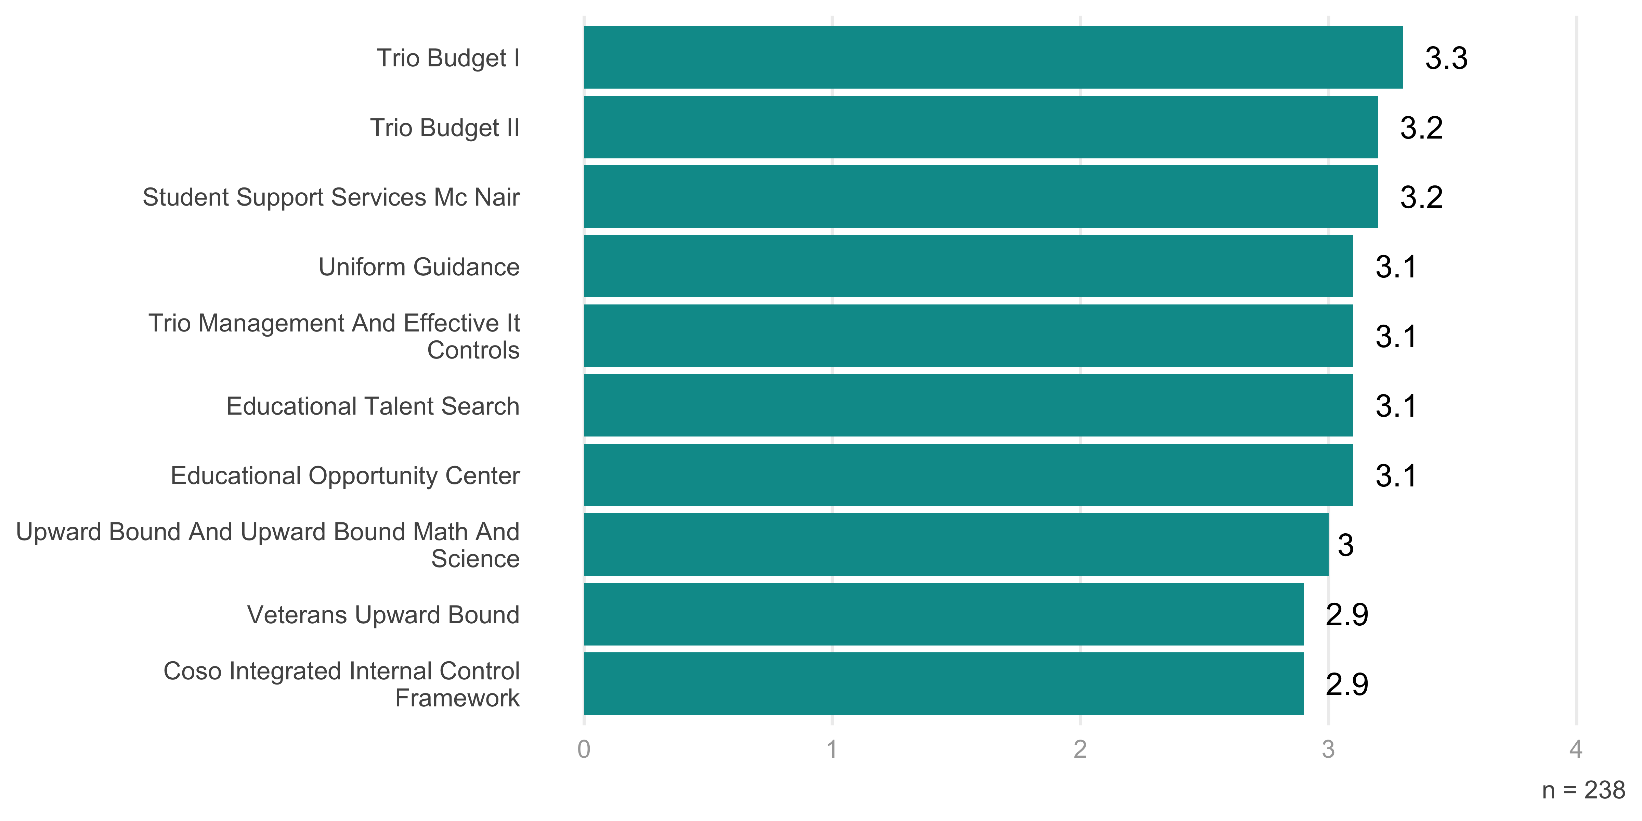

### Compare across training sessions

Looking at ratings across sessions, there is a bit more variation. The average rating for all courses was highest for in person trainings (3.2), followed by online sessions (3.0) and hybrid sessions (2.8). The figure below breaks this down by course, comparing ratings across types of training.

Figure 6: 2018 Course Ratings by Training Session

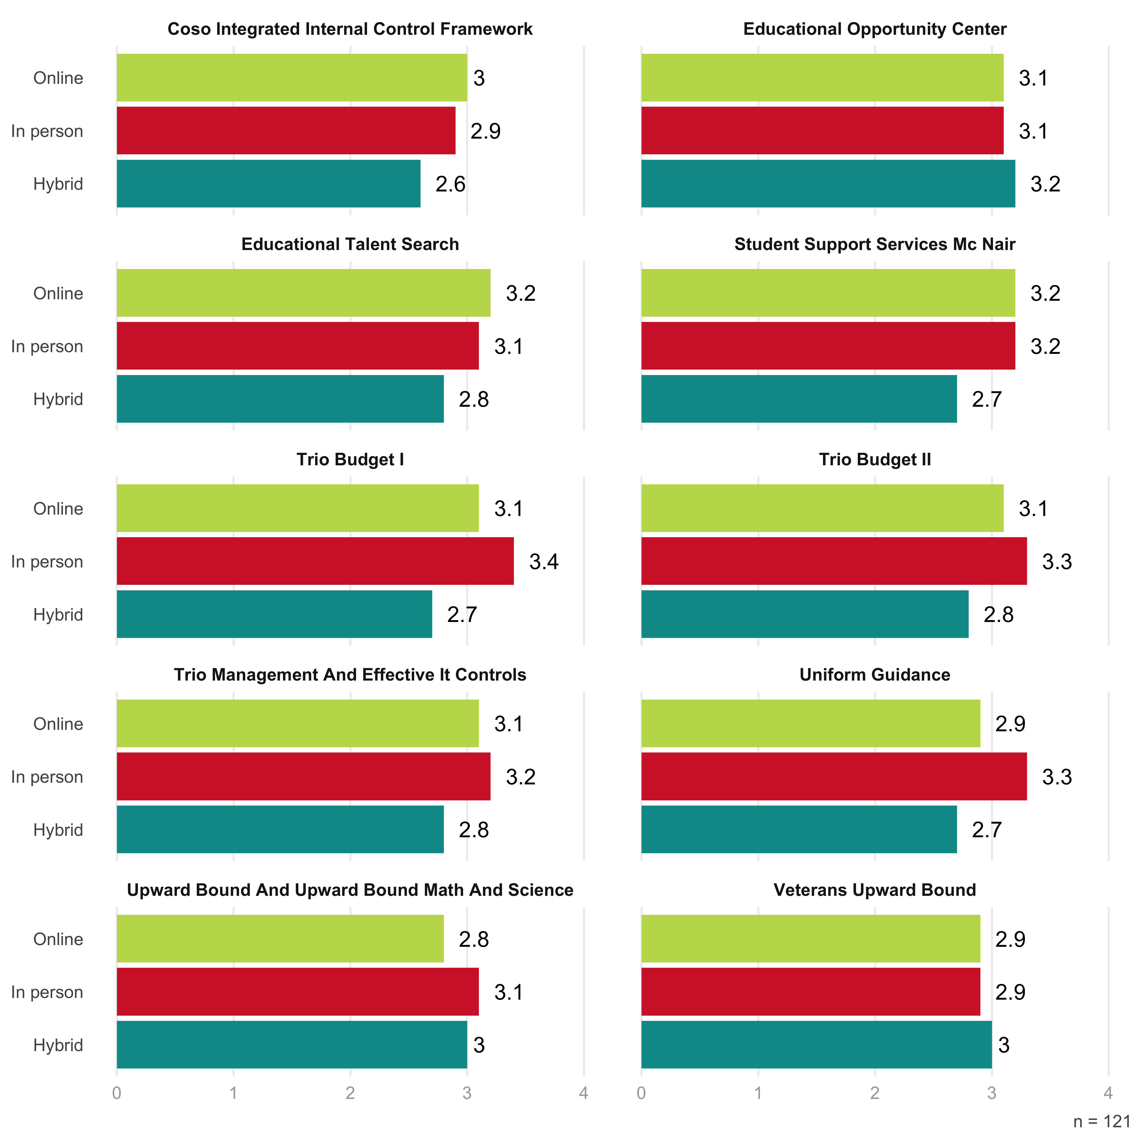

### Compare sessions types from 2017 to 2018 (i.e. compare hybrid across two years)

We can also compare ratings between the same types of sessions over the two years they have taken place. The set of figures below show the ratings given in 2017 and 2018 for online, hybrid, and in person courses.

#### Online

For the online courses, the ratings between the two years are largely similar. The one course that had a noticeably higher rating in 2017 than 2018 was Uniform Guidance. 2018 saw higher ratings for the Veterans Upward Bound course. Figure 7: Online Course Ratings 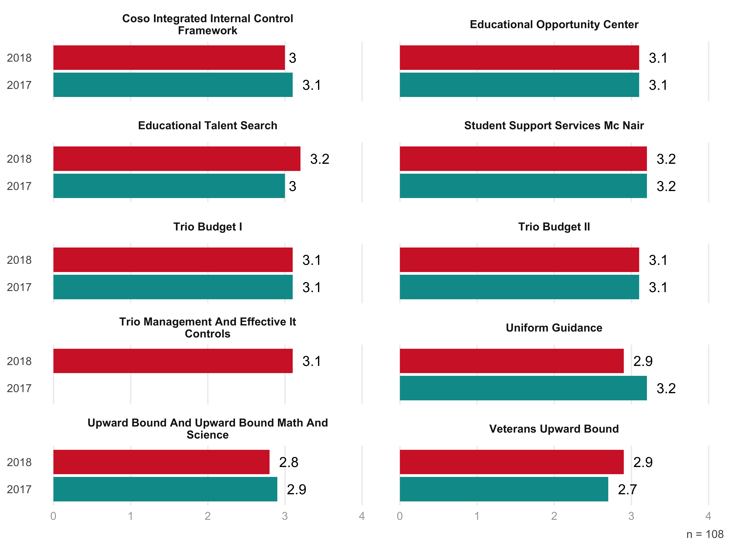

#### Hybrid

For hybrid courses, there are larger differences in the ratings between 2017 and 2018. The two courses with the biggest gaps are Veterans Upward Bound (3.0 in 2018, 2.5 in 2017) and Student Support Services McNair (2.7 in 2018, 3.2 in 2017). Figure 8: Hybrid Course Ratings 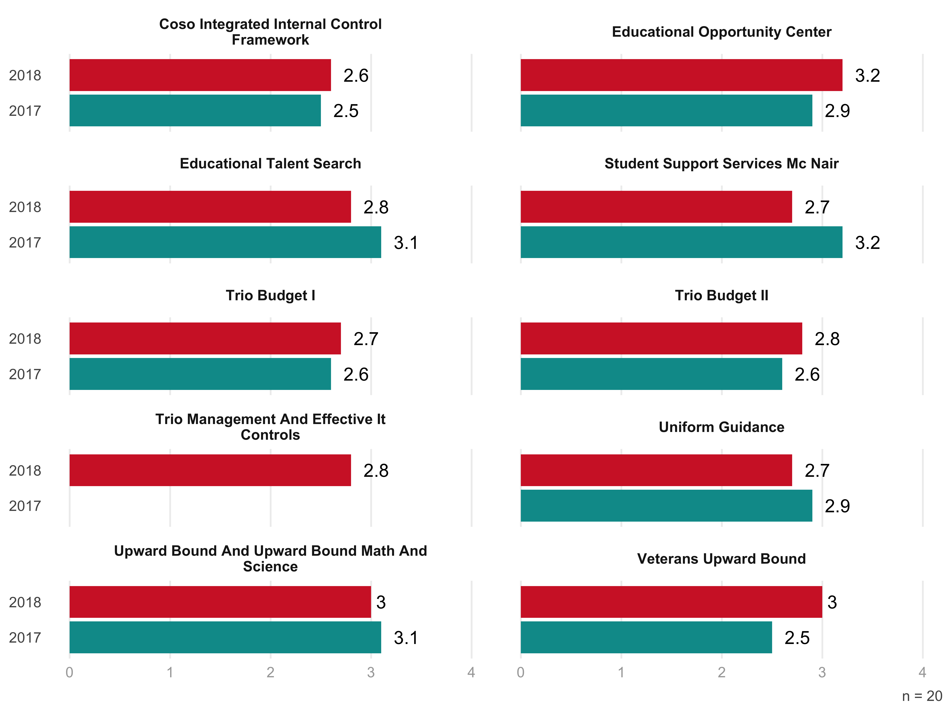

#### In Person

In person courses also showed some differences between this year and last year. The Education Opportunity Center course jumped from an average rating of 2.6 in 2017 to 3.1 in 2018. In contrast, the Upward Bound and Upward Bound Math and Science course dropped from 3.4 to 3.0. Figure 9: In Person Course Ratings 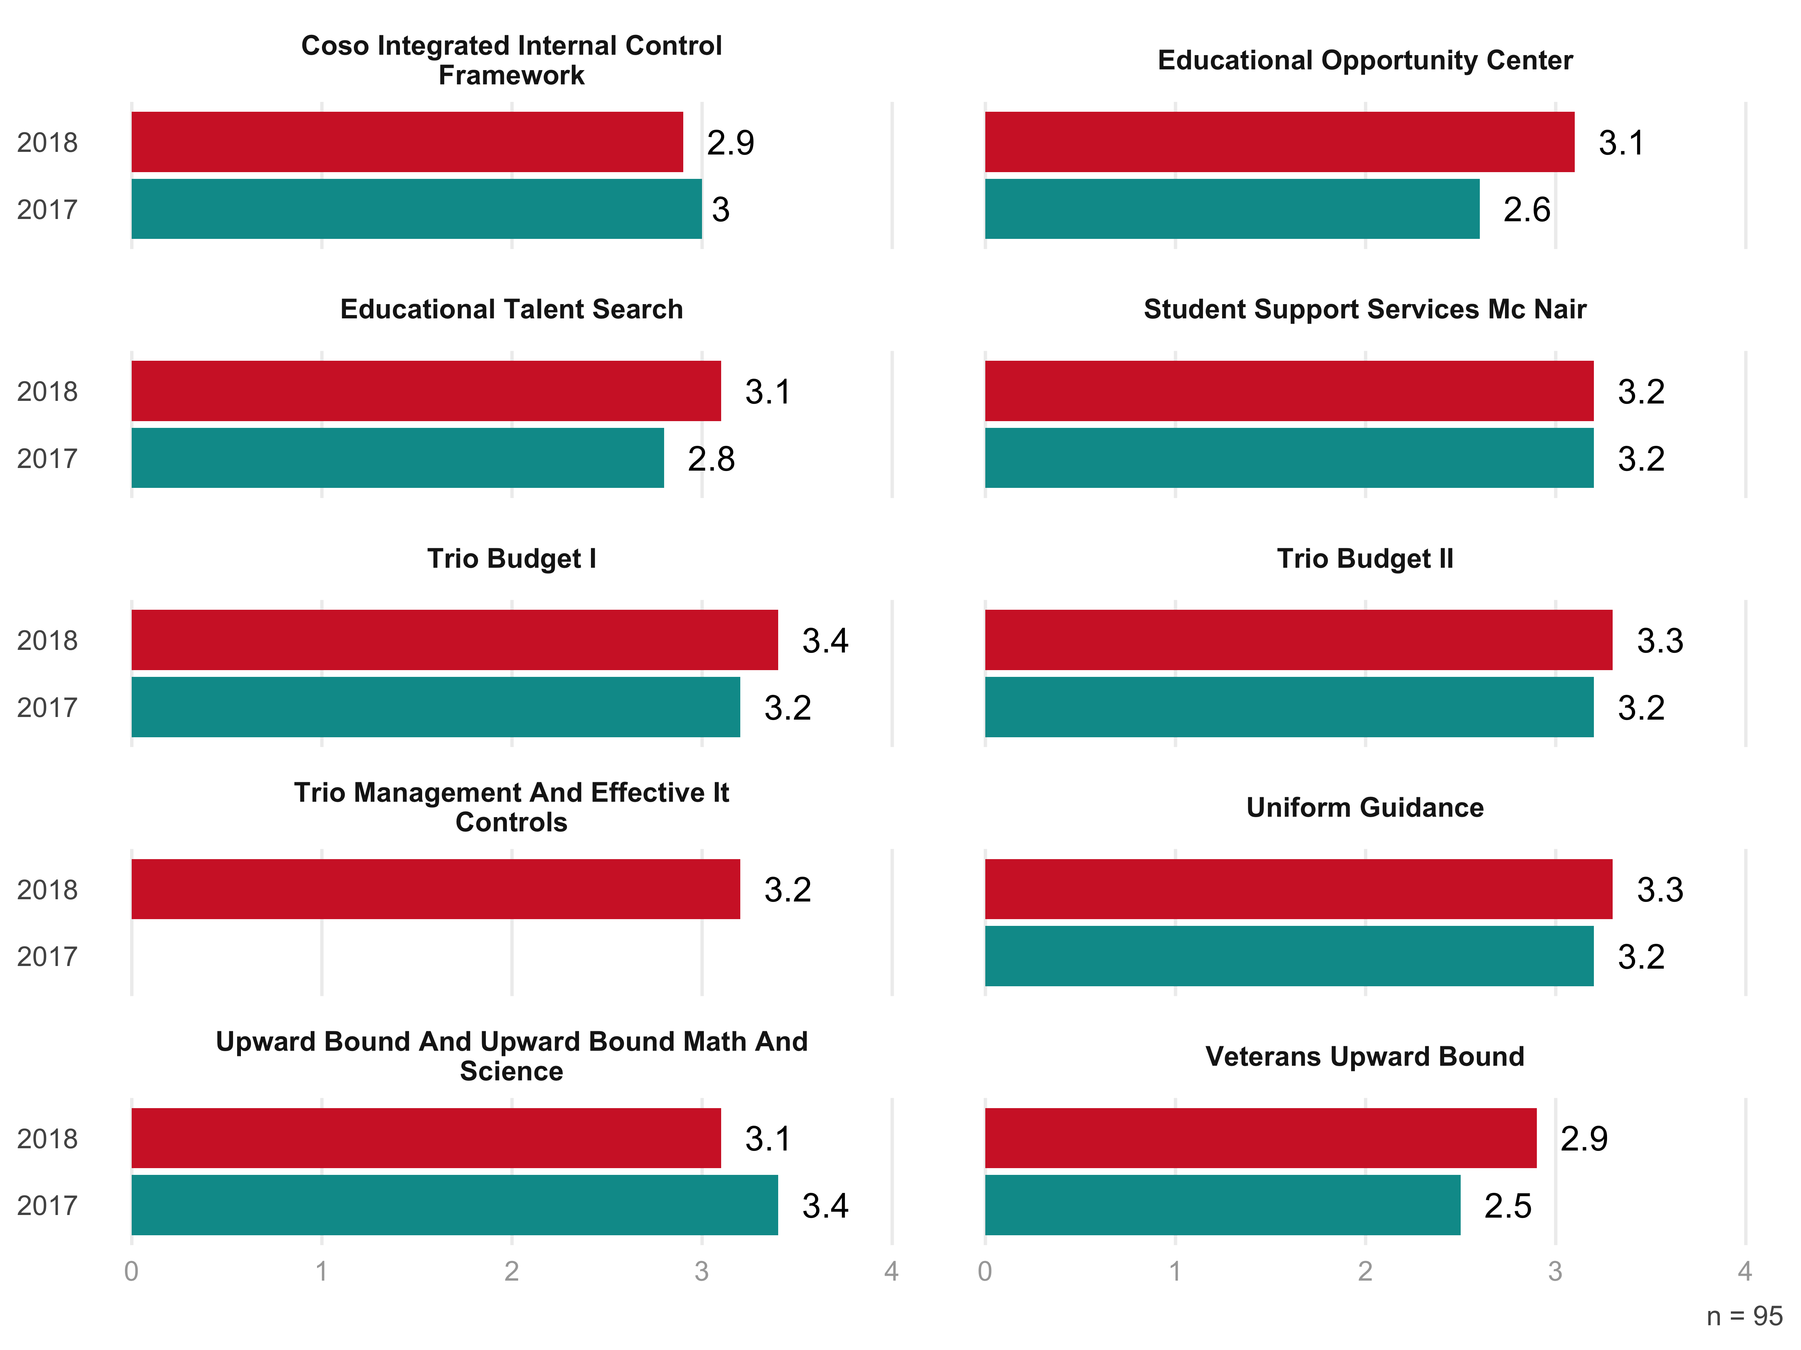

### To what extent were your general expectations of the training met?

* It was a very well thought training. I missed the first day so I’m looking forward to getting the link so I can increase my knowledge. I found everything very pertinent to my job, even though I am not a TRIO staff member.
* I thought it was worth while. I would have liked to have more of a hands on experience working with regulations and what we are allowed to do. Ex. Scenarios now justify why we can do such activity and cite rule.
* It covered a lot of what I wanted to know and gave me confirmation regarding some of our spending activities, which people tend to ignore because how great someone’s idea seems to be.
* The majority of my expectations were met. This training is needed to all those new to TRIO upon hire! This is really the “meat and gravy” of the projects.
* I am new to TRiO so I really did not know what to expect. The training was very informative , thorough and very well explained. It helped me tremendously.
* My expectations were met by attending this training. I learned a great deal more about legs. & regs and how they specifically relate to TRIO budget.
* As a new employee, I was prepared to absorb all information. On the whole, the training met my expectations by increasing my knowledge in all areas.
* Very much. I did not know anything of the subjects covered, but I now know a lot more about the different rules and regulations behind the programs.
* This was different than any other TRIO training I’ve attended so I’d say my expectations were met though in a way different than I anticipated
* The training was a great refresher course and assisted with solving one particular issues that we were experiencing with our program.
* The training was informative, well-organized, and engaging. I have a much better understanding of TRiO budgeting and documentation.
* Somewhat met - I would prefer a LIVE trainer rather than watching videos of training (Damon Hacker and Plante Moran, LLC)
* I received the necessary information in order for me to make informed decisions regarding the administration of my grant.
* Very informative. Lots of information to understand. By day 3 I felt a better understanding of acronyms used.
* Overall, the training exceeded my expectations. I gained information on internal controls and IT controls.
* Being new to TRIO, this has been the most exposure I have had. Training was excellent, very beneficial!
* Allowable and unallowable costs were my main concern and this training covered what I needed to know
* This was my first TRiO Training, so I wasn’t sure what to expect, but it was very informative.
* Expectations were met by providing a thorough overview of the program and resources available
* My general expectations of learning about budgets, legislation, and regulations were met.
* I honestly did not know what to expect. This is the first TRiO training that I received.
* My expectations were met beyond of what I thought I will learn before the training.
* Training was informative and provided a rational for why some decisions are made.
* Medium - We talked at high level about best practices, but less about specifics.
* They were met I learned a lot about budgeting and what is and what isn’t allowed
* I expected greater depth into the legs and regs so my expectations were not met
* I was very satisfied with my expectations and what was delivered to meet them.
* It was met - I received the information I had hoped to during the training.
* I only expected to learn about budgeting, but I learned much more than that
* I have a better understanding of TRIO and how the program as a whole works.
* I felt the training was very well presented with knowledgeable presenters.
* I figured the information would be provided, but expected it to be boring
* Way above average. They were organized, great speakers and information.
* To be introduced to topics I wasn’t informed on prior to this training.
* The second and third days of the training were more what I expected.
* To gain and increase foundational knowledge on the presented topics
* I learned some things that I did not know, so it was beneficial.
* To have a better understanding of management of the TRiO budget
* They were met, would loved to be able to some working examples.
* I have gained knowledge in all of the topics at the training
* To gain a more thorough knowledge of TRiO and how it works.
* I thought that it was more comprehensive that I anticipated
* I learned way more than I anticipated. Great information!
* Gaining a better understanding of TRIO budget management
* It was my first training. So, my expectations were open.
* The training covered everything I expected it to cover.
* My expectation were met during this Priority Training .
* I learned a lot about TRIO budgeting and legs and regs
* The presenters went above and beyond my expectations.
* Needed overview of budget management and received it
* To become more familiar with the TRIO regulations.
* This section covered all the items I need to know
* My general expectations were met very adequately
* The training was more detailed than I expected.
* It definitely met or exceeded my expectations
* I feel that the training met my expectatons.
* The training definitely met my expectations.
* This training went beyond what I expected!
* I had some understanding of this already
* Just wanted to learn as much as I could.
* All expectations were met or exceeded.
* The training exceeded my expectations.
* Had no expectations, so It went great.
* My expectations are definitely met.
* Great Information Above expected
* Amazing! I really learned a lot!
* All of my expectations was met.
* My expectations were exceeded.
* All my expectations were met.
* Consistent with expectations.
* General expectations met well
* Well beyond what I expected!
* I expected a brief overview.
* Way exceeded my expectations
* All my expectations were met
* The training did a good job.
* Expectations generally met.
* Expectations were exceeded.
* Exceeded my expectations.
* Fully met my expectations
* Expectation were exceeded
* My expectations were met.
* Exceeded my expectations
* My expectations were met
* Exceeded my expectations
* Expectations were met.
* Higher than I expected
* To the highest extent
* Low to Medium level
* Yes, very helpful!
* I didn’t have any.
* Very informative
* Very well met.
* Very much met.
* They were met
* A good extent
* They were met
* Some what met
* All of them.
* Very pleased
* Completely
* Exceeded

## Satisfaction with Aspects of the Training

### 2018 altogether

Figure 10: Overall Satisfaction with Aspects of TRIO Trainings

Looking at participants’ satisfaction with variuos aspects of the TRIO training sessions, we can see that they were most pleased with opportunities to ask questions and receive feedback. The lowest satisfaction ratings came in relation to quizzes (3.1 out of 4). 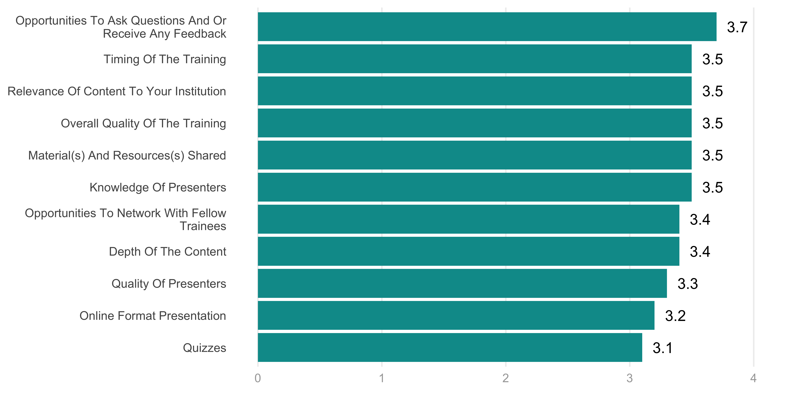

### Compare across training sessions

Comparing across type of trainings, it is clear that the most highly-rated courses were those given in the in person format. These courses had an average rating of 3.6. Hybrid courses and online courses both had average ratings of 3.2.

Breaking this down by individual aspects of satisfaction, you can see below the how participants rated each type of training in each area.

Figure 11: Overall Satisfaction with Aspects of TRIO Trainings by Training Type 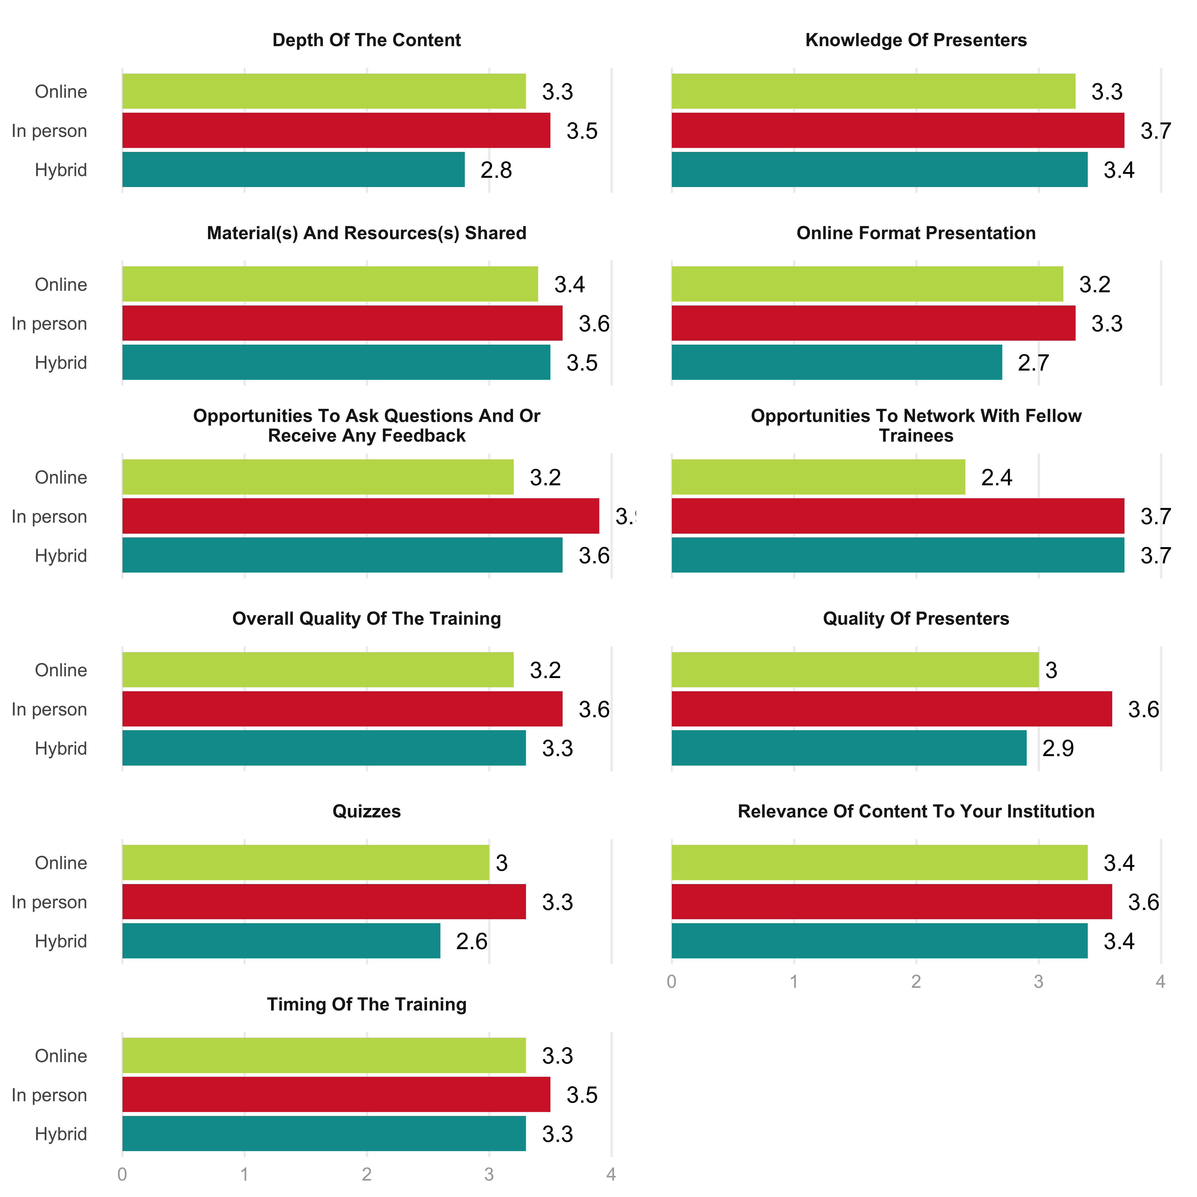

### Compare sessions types from 2017 to 2018 (i.e. compare hybrid across two years)

#### Online

Comparing satisfaction levels between years, we can see that the ratings are higher for 2018 than they were in 2017. Particularly notable is the question around opportunities to ask questions and receive feedback. This item had an average rating of 2.6 in 2017, but jumped to 3.2 in 2018. This was likely the result of the Q&A sessions that organizers added this year.

Figure 12: Online Course Satisfaction 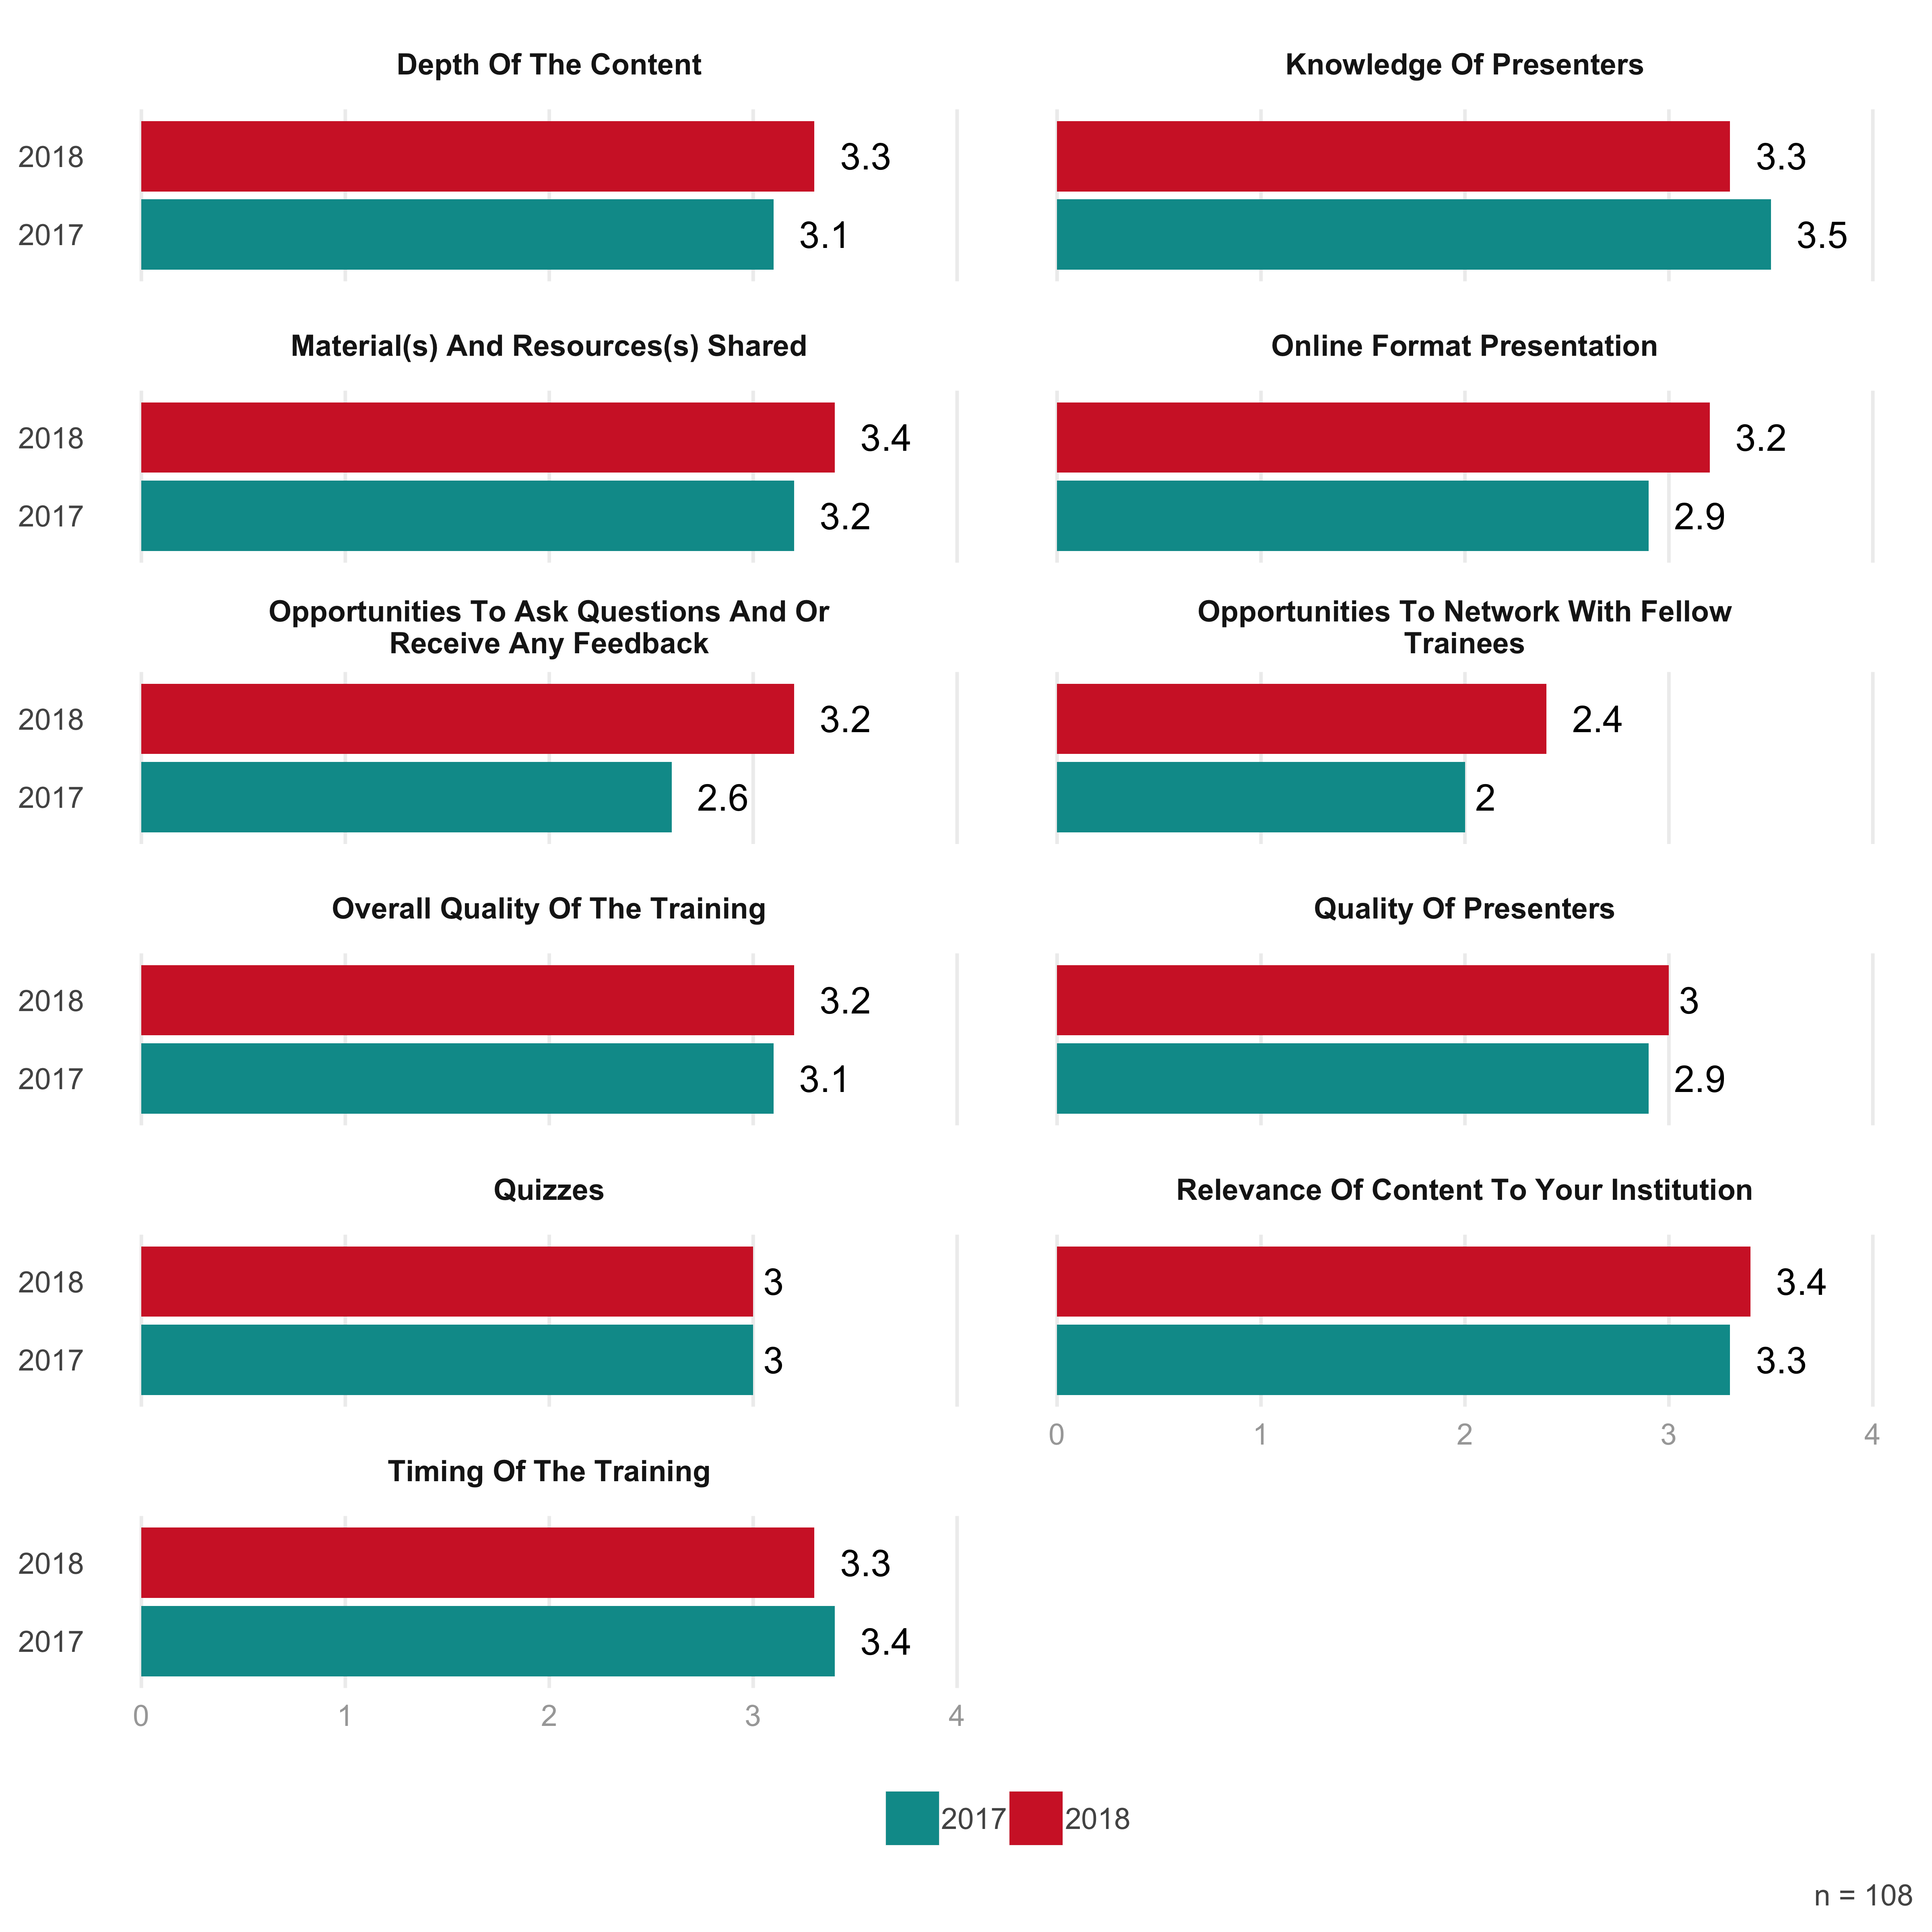

#### Hybrid

For hybrid sessions, the largest gap was on opportunities to network with fellow trainees. The 3.7 rating in 2018 was a full point above the 2.7 rating in 2017. The one area of concern is with regard to depth of content, which dropped from 3.4 in 2017 to 2.8 in 2018.

Figure 13: Hybrid Course Satisfaction 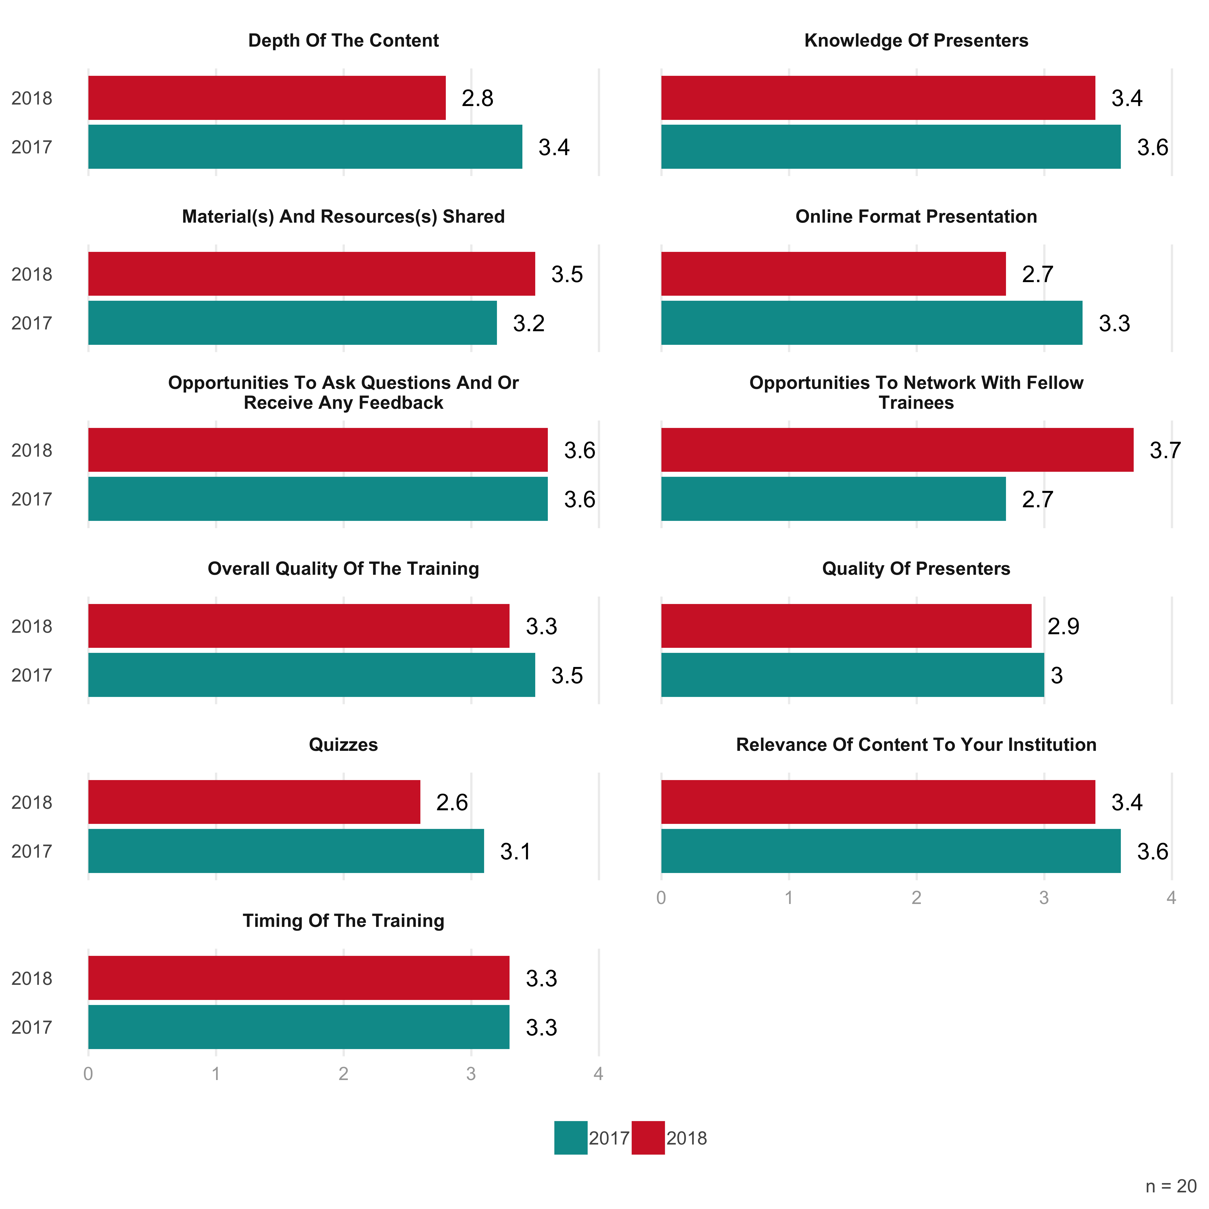

#### In Person

In person trainings saw growth in satisfaction levels in every area.

Figure 14: In Person Course Satisfaction 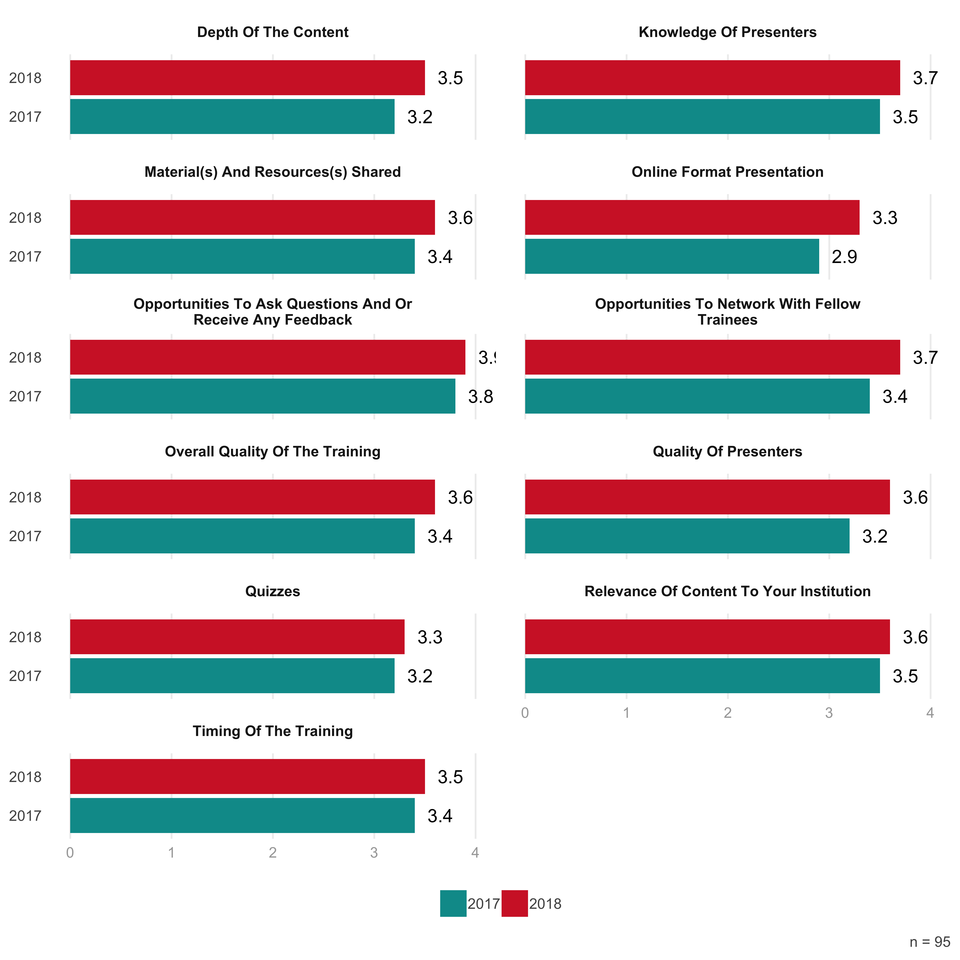

### If you rated low or medium, please mention why.

* I’m on the west coast, so the live webinar was too early for me (did not get to participate if i wanted) - but nichelle was prompt and helpful, material and resources was medium because not all videos were provided and i REALLY wanted to be able to download IT Control Mod 3’s video, the quizzes were sometimes asking questions before the material was covered (IT’s questions were all after Mod 2 but was asking questions covered in Mod 3. Other sections sometimes did the same thing but i can’t remember which ones). Also, sometimes the quiz questions just gave you the answer (in the question, not after you completed it).
* A medium rating was selected for the quality of presenters for the mere fact that the first two presenters read to us from the powerpoint. The information was great, but the presentation was dry which made it hard to stay focused.
* The benefits of having a live speaker are being able to ask questions directly and more lively engagement. I found the videos to be boring and slightly disappointing although the organizers were delightful and generous hosts.
* Online version- did have webinar- the presenters were most likely knowledgeable; however, they were reading the material- they could have posted slides, and I could have read the material myself.
* There were no networking opportunities build into the LMS. Again mediums were used as the training sessions only allow for a short time to be exposed to and digest the materials.
* The trainings varied from day to day. I thought the program specific session was great as were the budget sessions. The first day, however, was not very helpful.
* Quizzes were okay but don’t feel they were necessary. For questions at the end of the training, the times were not stated that they were Eastern Standard time.
* It was very difficult to stay focused with the on-line option. The information and way it was provided was very monotone at times.
* Quizzes varied regarding what they focused on. On one quiz, I accidentally took it before watching the module and I passed anyway.
* The level of difficulty of the quizzes were inconsistent. Not all of them were helpful in reinforcing the information.
* I might be useful to add some more small group discussion options with others attending the training.
* The quizzes were more a fun activity, nice touch, but not what I would consider “testing” really.
* Quizzes were more for information which is fine, but some people were ready for more of a game.
* Some of the presenters read straight from a script - it wasn’t very dynamic or engaging.
* Last presenter was very monotone and made it hard to concentrate on info he was sharing.
* -Not everything covered applied to my institution since we are a relatively new program
* I wasn’t aware of opportunities to network with fellow trainees if there was any.
* The script and the PPT pages seemed to be on different tracks at times.
* Since it was online, there was no interaction between other trainees.
* On-line format doesn’t really allow for effective networking
* Should have been more in depth into the legs and regs
* Presenters mostly read from the presentation slides.
* The lowest mark is because of the online format.
* It happened during the Trio Conference.
* I like lots of scenarios and examples.
* My expections may have been to high.
* Didn’t know we could network..??
* The food was terrible
* Medium=Good.

## Knowledge Growth

### 2018 altogether and comparing to last year

Figure 15: Knowledge Growth 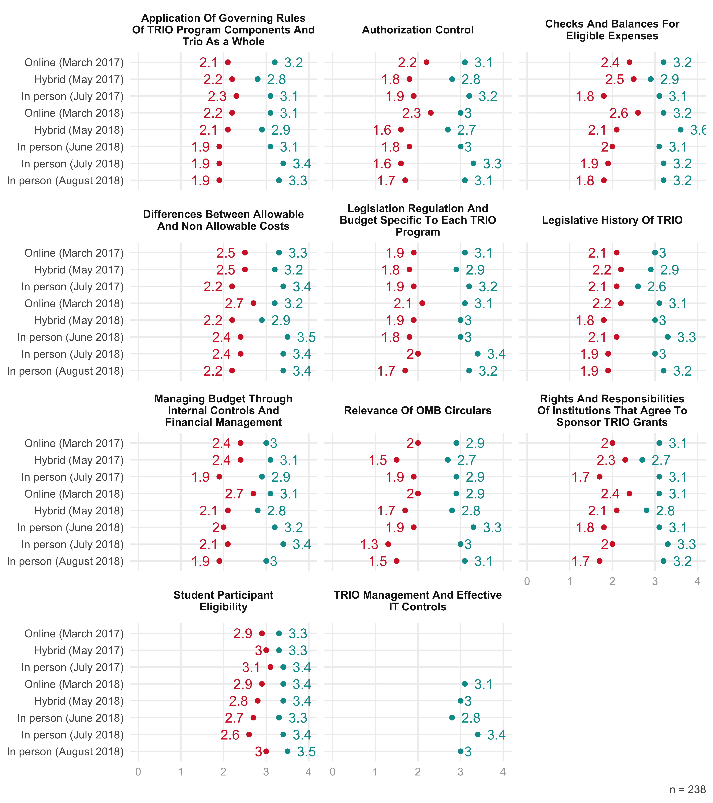

# Other

## Other topics

* Creative resourcing for programming -I’d love to see a master list/document that could be contributed to and shared by all of us that has ideas for ways to do effective programming on the cheap, and in general what other programs are doing to serve their students.
* I would like to see a training for new directors. I don’t know if you offer it, but I would definitely sign up for it. I liked that the training was at my time and pace.
* How to communicate with institutional staff about compliance, and how to build a relationship with them, i.e. Grant accountants, provost, others
* I would like to see you go into more detail about preparing a budget, the budget narrative, and what happens when your plans change.
* Leadership focused training. How to be a leader in the program for staff, students, colleges/organizations, and for the community.
* Go in depth as to why some programs are able to get shirts depite it saying in the “regs” an “legs” that it is not permissible.
* It would be helpful to try to combine the auditing portion and have more hands tools for staff preparing for a an audit.
* Advocating your rights to spend the money and how to continue the communication process with your host institution
* I feel as though you covered way beyond what I expected. I did not even know I needed to know those things!
* What is considered allowable and unallowable for each program such as specific examples
* I would have liked to have heard about TRIO current events/in the news… Future of Trio
* Maybe real life scenarios, 10, discussion relevant to each position in split outs
* Separate topics such as (how to determine) eligibility, low income, Vet status
* Less talk about ITS and Auditor portion more about a trio audits and senerios
* Maybe a more time for round table discussion in the TRIO breakout sessions
* More trio specific details about implementing internal controls.
* Leadership, work management and how to handle difficult students
* More on records retention, especially digital vs. Paper
* I don’t think so - you covered all of the must have’s.
* External/Internal Audit Preparation: What to Expect
* How to write a TRIO program grant for New Directors
* More coverage on Uniform Guidance Cost Principles
* I would like to cover Peer Audits a bit more.
* Maybe offer 2 break out sessions; one
* Can’t think of any at this time.
* Examples of Change of Scope,
* Build a mock program budget
* No suggestions at this time
* Not that I can think of.
* Not that I can think of
* Nope! Great coverage!
* It was well covered.
* See above comments
* Not at this time.
* TRIO Legislation
* Not at this time
* More on audits
* New Director
* Not sure

## Want follow-up session

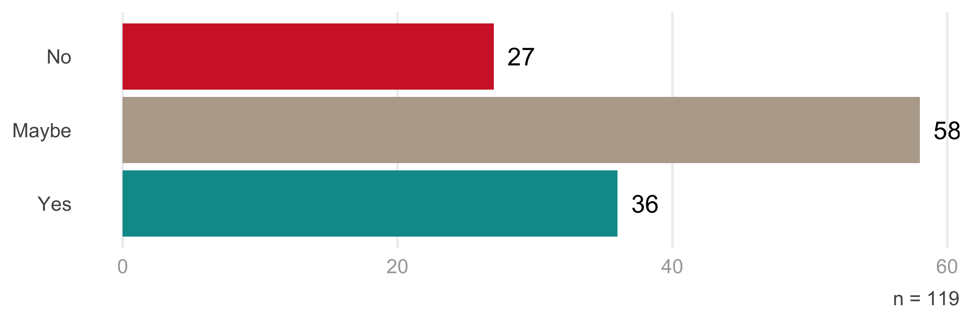

## Recommend to colleague

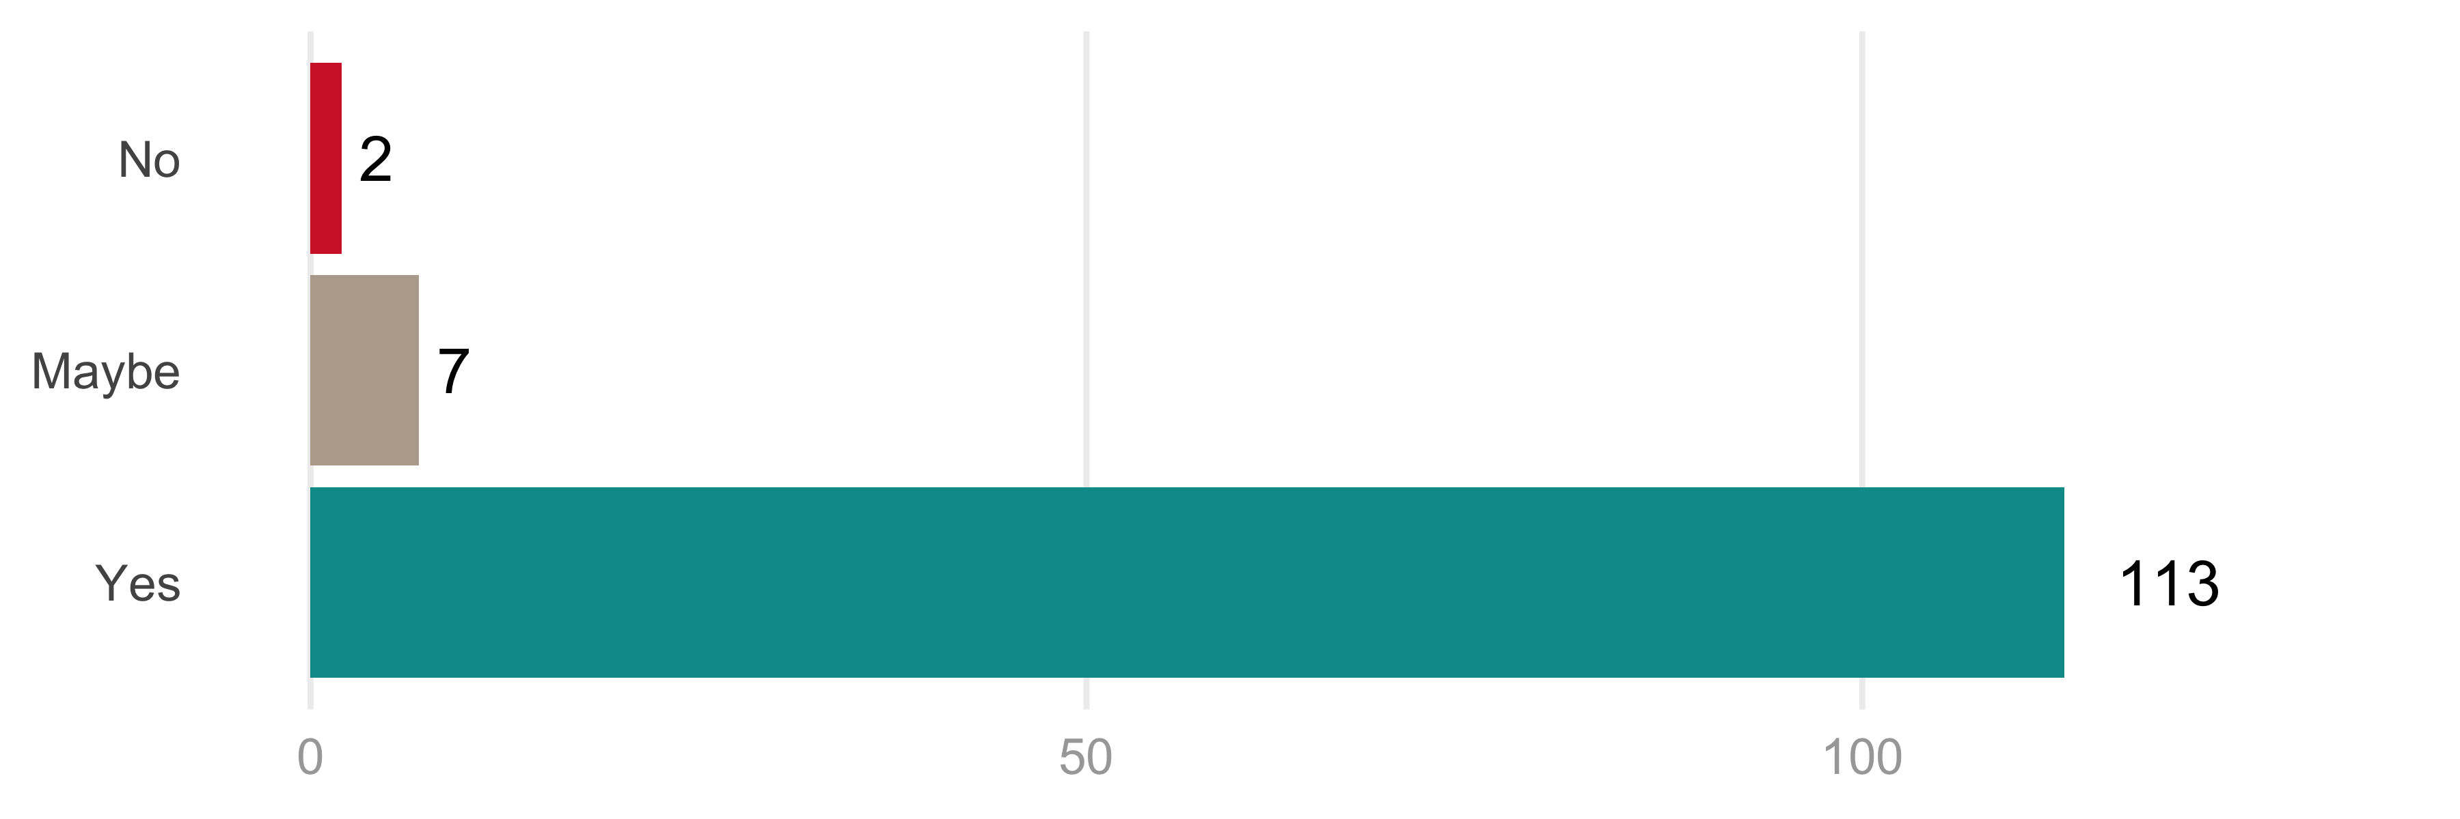

# Conclusion

Q&A in online courses helped # Areas of improvement

From last year

* Make online courses more interactive
* Make sure that the training is tailored to the specific needs of those taking part.
* Ensure that all participants have reference guides they can use after the trainings.
* Provide a buddy peer support system.